

ISTD 50.002 Computation Structures

**Lab #5 Beta**

Introduction

STEP 1: Building up the Beta to be able to Execute a Basic Block of Instructions

PC

REGFILE

CTL

Memory Unit

BSEL mux

WDSEL mux

Test the Circuit

STEP 2: Adding Support for Transfers of Control

Part A

Part B

Part C

Part D

Part E

Part F

Test the Circuit

Appendix 1: What’s the cycle time of your Beta?

Appendix 2: Using the JSim memory component

Revamped by: Kenny Choo, Natalie Agus, Oka Kurniawan 2020.

## Due Date

Refer to the [course handout](https://docs.google.com/document/d/10G-WRqCuoDnmcUJH6keefA_oOU1KshD1UI8jnKo4dig/edit?usp=sharing) for due date.

# Introduction

|  |
| --- |
| **Preparation**: the [description of the Beta implementation](https://natalieagus.github.io/50002/building_beta.html#detailed-anatomy-of-the-beta-cpu), the ALU function code from [Lab #3](https://docs.google.com/document/d/1zEqh83Nf-CgN_T9J-1Yy2A9vCC9y-K0erl1JmX63dj8/edit?usp=sharing), the lecture on [Beta Datapath](https://natalieagus.github.io/50002/building_beta.html#memory-access-datapath), and the [Summary of Instruction Formats](https://drive.google.com/file/d/1v-eaGuxa1W5HPPNi_shvdS1g5z99if3_/view?usp=sharing) will be useful when working on this lab. **NOTE: this is a long assignment, so plan accordingly!** |

The goal of this lab is to complete your Beta design. We will do it in two steps: **STEP 1**: first get the design to the point where it can execute a “basic block” of instructions, i.e., a sequence of instructions that does not contain any branches or jumps. And **STEP 2**, add the circuitry to handle transfers of control (JMP, BNE, BEQ). The following diagram of a simplified Beta that can execute basic blocks shows what needs to be done for the first step:

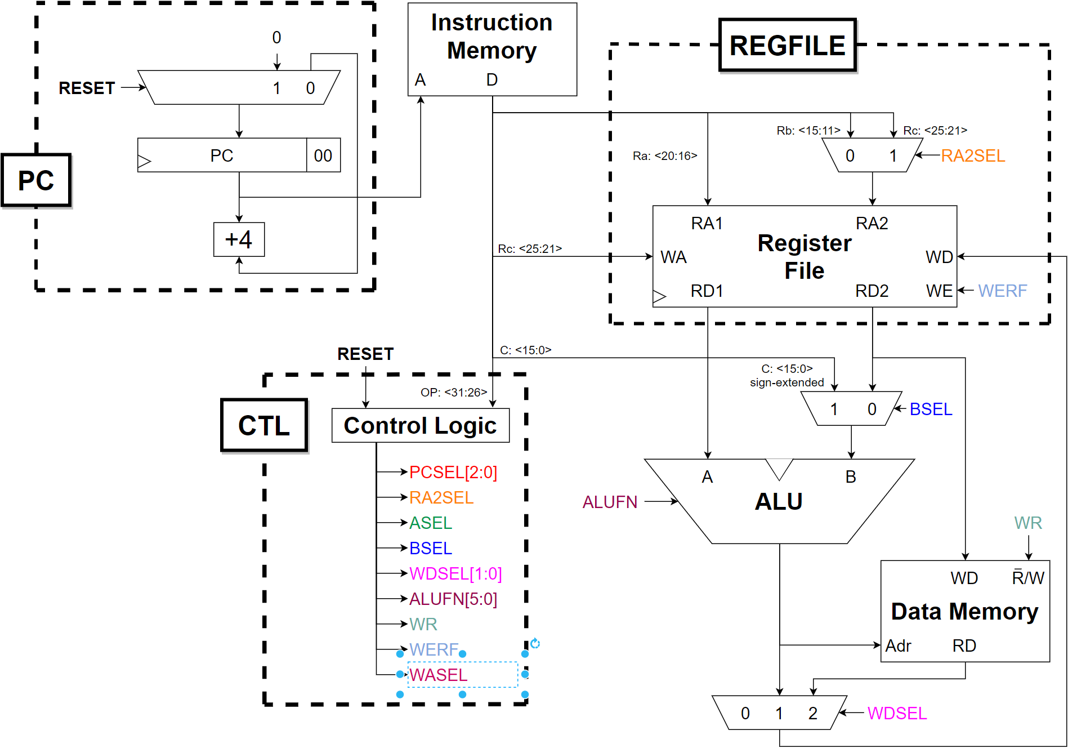

###### Fig 1: Diagram of a Simplified Beta

# STEP 1: Building up the Beta to be able to Execute a Basic Block of Instructions

Let us tackle this step in stages. Here are some step-by-step design notes keyed to the dotted-line boxes in the block diagram shown above.

## PC

The 32-bit multiplexer (mux) selects the value to be loaded into the PC at the next rising edge of the clock. Eventually the mux will have inputs used for implementing branches, jumps, exceptions, etc. but for now use a two-input 32-bit mux that selects 0x00000000 when the RESET signal is asserted, and the output of the PC+4 logic when RESET is not asserted. We will use the RESET signal to force the PC to zero during the first clock period of the simulation.

The PC is a separate 32-bit register that can be built using the dreg component from the parts library. You should include hardware for the bottom two bits of the PC even though they are always 0; this will make debugging traces easier to interpret.

Conceptually, the increment-by-4 circuit is just a 32-bit adder with one input wired to the constant 4. You can implement it this way, but it is possible to build a much smaller circuit if you design an adder optimized knowing that one of its inputs is 0x00000004.

We have created a test jig to test your PC circuitry. Your netlist should incorporate the following three .include statements:

|  |
| --- |
| .include "/50002/nominal.jsim"  .include "/50002/stdcell.jsim"  .include "/50002/lab5pc.jsim" |

and the following subcircuit definition (you can of course define other subcircuits as well)

|  |
| --- |
| .subckt pc clk reset ia[31:0]  … your mux/register/+4 circuit here …  .ends |

## REGFILE

The register file is a 3-port memory. Here’s a template netlist for specifying the 3-port register file:

|  |
| --- |
| Xregfile  + vdd 0 0 ra[4:0] adata[31:0] // A read port  + vdd 0 0 ra2mux[4:0] bdata[31:0] // B read port  + 0 clk werf rc[4:0] wdata[31:0] // write port  + $memory width=32 nlocations=31 |

See Appendix 2 for a more complete description of how to use the $memory JSim component.

Note that the memory component doesn’t know that location 31 of the register file should always read as zero, so you’ll have to add additional logic around the memory that makes this happen. You can use muxes or ANDs to force the register data for each read port to “0” when the port address = 0b11111 (i.e., R31). And you will need a mux controlled by RA2SEL to select the correct address for the B read port.

We’ve created a test jig to test your register file circuitry. Your netlist should incorporate the following three .include statements:

|  |
| --- |
| .include "/50002/nominal.jsim"  .include "/50002/stdcell.jsim"  .include "/50002/lab5regfile.jsim" |

and the following subcircuit definition (you can of course define other subcircuits as well)

|  |
| --- |
| .subckt regfile clk werf ra2sel ra[4:0] rb[4:0] rc[4:0]  + wdata[31:0] radata[31:0] rbdata[31:0]  … your register file circuit here …  .ends |

## CTL

The control logic should be tailored to generate the control signals your logic requires, which may differ from what’s shown in the diagram above. Note that a ROM can be built by specifying a memory with just one read port; the ROM contents are set up using the contents keyword in the netlist description of the memory. For example, the netlist for a ROM that uses the opcode field of the instruction to lookup the values for 18 control signals might look like:

|  |
| --- |
| Xctl vdd 0 0 id[31:26] // one read port  + pcsel[2:0] wasel asel ra2sel bsel alufn[5:0] wdsel[1:0] werf moe xwr  + $memory width=18 nlocations=64 contents=(  + 0b000000000000000000 // opcode=0b000000  + 0b000000000000000000 // opcode=0b000001  + …  + ) |

*Most* of the signals can connect directly to the appropriate logic, e.g., ALUFN[5:0] can connect directly to the ALUFN inputs of your ALU. During this step, we won’t be using PCSEL[2:0], WASEL or ASEL, so you can set the corresponding bits in each ROM location to zero.

We do need to **be careful with the write enable signal for main memory (WR)** which needs to be valid even before the first instruction is fetched from memory. So you should include some additional logic that forces WR to 0 when RESET=1 – the signal XWR from the ROM needs to combine appropriately with RESET to form WR. MOE is another memory control signal; see the next section for more information.

We will be adding more bits to the control ROM when the branch logic is added in the next lab. For this lab, your design should implement the following instructions:

LD, ST,

ADD, SUB, CMPEQ, CMPLT, CMPLE,

AND, OR, XOR, SHL, SHR, SRA,

ADDC, SUBC, CMPEQC, CMPLTC, CMPLEC,

ANDC, ORC, XORC, SHLC, SHRC, SRAC

Eventually unimplemented instructions will cause an exception, but for now turn them into NOPs by making sure WERF is set to 0 (preventing any value from being written into a destination register).

If you have followed the scheme outlined above, we have created a test jig to test your control circuitry. Your netlist should incorporate the following three .include statements:

|  |
| --- |
| .include "/50002/nominal.jsim"  .include "/50002/stdcell.jsim"  .include "/50002/lab5ctl.jsim" |

and the following subcircuit definition (you can of course define other subcircuits as well)

|  |
| --- |
| .subckt ctl reset id[31:26] ra2sel bsel alufn[5:0] wdsel[1:0] werf moe wr  … your control circuit here …  .ends |

## Memory Unit

The Memory Unit is broken into two sections for clarity: the instruction memory and data memory. These two will be supplied by lab5checkoff.jsim; you just need to set the Beta to supply the appropriate signals to each unit:

* **instruction address** (ia[31:0], **output** of the Beta to instruction memory). Address of next instruction to be executed.

In order to obtain the:

* **instruction data** (id[31:0], input to the Beta from instruction memory) from lab5checkoff.jsim.

Note: *After the appropriate* ***propagation*** *delay, the memory unit will supply the Beta with the contents of its memory location specified by ia[31:0].*

When the Beta wants to ***load* (read)**data from the memory, it needs to supply two things:

* **data memory address** (ma[31:0], **output** of the Beta to data memory) from lab5checkoff.jsim. This is the **address** of data memory location to be **read (load)** or **written (store)**, and,
* **memory output enable** (moe, **output**  of the Beta to data memory). This is set to 1 when the Beta wants the memory to fetch the data at the memory location specified by ma[31:0].

And the memory unit will supply the data at memory address ma[31:0] to the beta as:

* **memory read data** (mrd[31:0], input to the beta from data memory).

If the Beta wants to ***store* (write)** data to the memory, it needs to supply two things:

* **memory write data** (mwd[31:0], **output** of the Beta to data memory) -- the 32-bit data to be stored to the memory unit, and,
* **memory write enable** (wr, **output** of the Beta to data memory). Set to 1 when the Beta wants to store into the memory location specified by ma[31:0] at the end of the current cycle.

*WARNING:* for *this lab*, this signal should always have **a valid logic value (either 1 or 0)** at the rising edge of CLK **otherwise the contents of the memory will be erased**. If wr is 1, the data mwd[31:0] will be written into memory at the end of the current cycle. Otherwise, the data at mwd[31:0] will be ignored.

Your Beta design should include circuitry to generate all the signals labeled as “**output**”. Signals labeled as “input” will be driven by memory.

## BSEL mux

The low-order 16 bits of the instruction need to be sign-extended to 32 bits. Sign-extension is easy in hardware! Just connect inst[15:0] to the low-order sixteen D1 inputs of the mux and inst15 to each of the high-order sixteen D1 inputs.

## WDSEL mux

In the final design the 32-bit WDSEL mux will select the data to be written into the register file from one of three possible sources. For this lab, there are only two choices: the output of the ALU (WDSEL = 0b01) and read data from main memory (i.e., the data on mrd[31:0], WDSEL = 0b10).

## Test the Circuit

When you have completed the above steps, you can use lab5basicblock.jsim to test your circuit. Your netlist should incorporate the following three .include statements:

|  |
| --- |
| .include "/50002/nominal.jsim"  .include "/50002/stdcell.jsim"  .include "/50002/lab5basicblock.jsim" |

and the following subcircuit definition (you can of course define other subcircuits as well)

|  |
| --- |
| .subckt beta clk reset ia[31:0] id[31:0] ma[31:0]  + moe mrd[31:0] wr mwd[31:0]  … your circuit here …  .ends |

Your design will be tested at a cycle time of 100ns. The reset signal is asserted for the first clock edge and then deasserted to start the program running. This implementation of the Beta subcircuit has the following terminals:

clk input clock (from test circuitry)

reset input reset (from test circuitry)

ia[31:0] outputs instruction address (from PC register)

id[31:0] inputs instruction data (from test circuitry)

ma[31:0] outputs memory data address (from ALU)

moe output memory read data output enable (from control logic)

mrd[31:0] inputs memory read data (from test circuitry)

wr output memory write enable (from control logic)

mwd[31:0] outputs memory write data (from register file)

Lab5basicblock.jsim uses the following netlist to create the test circuitry:

|  |
| --- |
| // create an instance of the Beta to be tested  Xbeta clk reset ia[31:0] id[31:0] ma[31:0]  + moe mrd[31:0] wr mwd[31:0] beta  // memory is word-addressed and has 1024 locations  // so only use address bits [11:2].  Xmem  + vdd 0 0 ia[11:2] id[31:0] // port 1: instructions (read)  + moe 0 0 ma[11:2] mrd[31:0] // port 2: memory data (read)  + 0 clk wr ma[11:2] mwd[31:0] // port 3: memory data (write)  + $memory width=32 nlocations=1024 contents=(  + … binary representation of /50002/lab5basicblock.uasm …  + )  // clock has 100ns cycle time, starts as 1 so first clock  // edge happens 100ns into the simulation  Vclk clk 0 pulse(3.3,0,49.9ns,.1ns,.1ns,49.9ns,100ns)  // reset starts as 1, set to 0 just after first clock edge  Vreset reset 0 pwl(0ns 3.3v, 101ns 3.3v, 101.1ns 0v) |

Lab5basicblock.jsim checks out your design by attempting to run a test program and verifying that your Beta outputs the correct values on its outputs every cycle. The source for the test program can be found at /50002/lab5basicblock.uasm

The test program computes a “magic number” using a sequence of operations that tests the various pieces of your design. The program writes out a series of results into memory location 0x3FC; look at lab5basicblock.uasm to see what values are written on which cycles.

Lab5basicblock.jsim will verify that the instruction address (ia[31:0]), memory address (ma[31:0]), memory write data (mwd[31:0]) and the memory control signals (moe, wr) have the correct values each cycle. The check is made just before the rising clock edge, i.e., after the current instruction has been fetched and executed, but just before the result is written into the register file. Note that ma[31:0] is the output of the ALU, so these checks can verify that all instructions are working correctly. If you get a verification error, check the instruction that has just finished executing at the time reported in the error message – your Beta has executed that instruction incorrectly for some reason.

# STEP 2: Adding Support for Transfers of Control

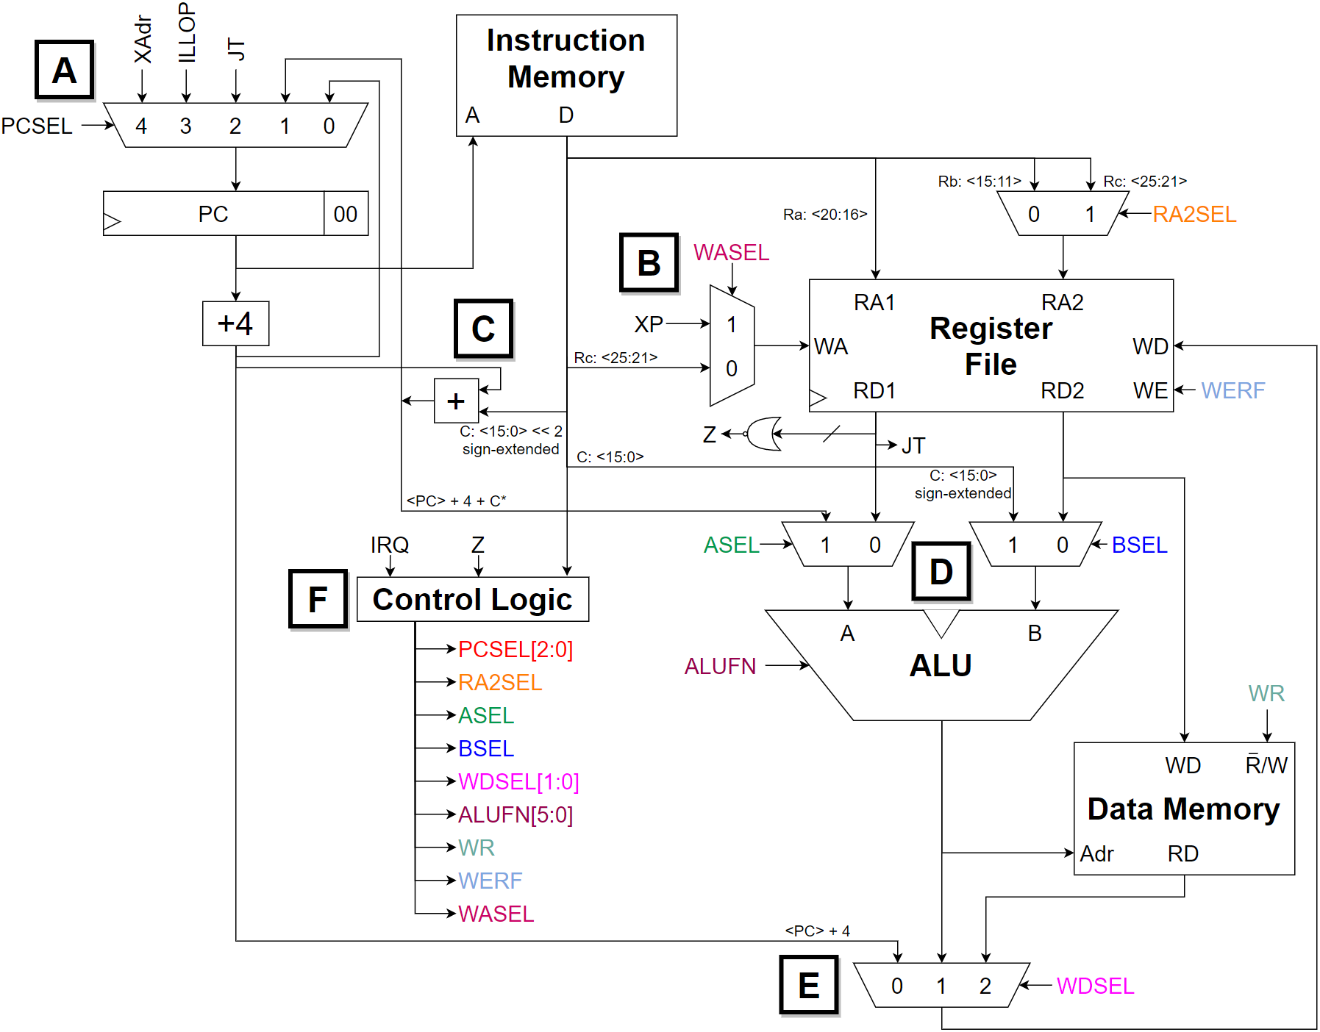

###### Fig 2: Diagram of Complete Beta

In this step you will complete the implementation of your Beta. We will take the block diagram from Step 1 and add the remaining logic. It is probably best to tackle the work in stages. Here are some design notes keyed to the block diagram shown above:

## Part A

Since the parts library doesn’t have any 5-input multiplexers, you will have to construct the logic that selects the next PC using other components and adjust the control logic accordingly. Remember to add a way to set the PC to zero on reset (see Part F). “XAdr” and “ILLOP” in the block diagram represent constant addresses used when the Beta services an interrupt (triggered by IRQ) or executes an instruction with an illegal or unimplemented opcode. For this assignment assume that XAdr=8 and ILLOP=4 and we will make sure the first three locations of main memory contain BR instructions that branch to code which handle reset, illegal instruction traps and interrupts respectively. In other words, the first three locations of main memory contain:

Mem[0x00000000] = BR(reset_handler)

Mem[0x00000004] = BR(illop_handler)

Mem[0x00000008 ] = BR(interrupt_handler)

**Note on Supervisor bit**: The high-order bit of the PC is dedicated as the “Supervisor” bit (see section 6.3 of the Beta Documentation). Instruction fetch and the LDR instruction ignore this bit, treating it as if it were zero. The JMP instruction is allowed to clear the Supervisor bit or leave it unchanged, but cannot set it, and no other instructions may have any effect on it. Only reset, exceptions and interrupts cause the Supervisor bit to become set. This has the following implications for your Beta design:

1. 0x80000000, 0x80000004 and 0x80000008 are loaded into the PC during reset, exceptions and interrupts respectively. This is the only way that the supervisor bit gets set. Note that after reset the Beta starts execution in supervisor mode.
2. Bit 31 of the PC+4 and branch-offset inputs to the PCSEL mux should be connected to PC31, i.e., the value of the supervisor bit doesn’t change when executing most instructions.
3. You’ll have to add logic to bit 31 of the JT input to the PCSEL mux to ensure that JMP instruction can only clear or leave the supervisor bit unchanged. Here’s a table showing the new value of the supervisor bit after a JMP as function of JT31 and the current value of the supervisor bit (PC31):

|  |  |  |
| --- | --- | --- |
| **old PC31** | **JT31** | **new PC31** |
| 0 | -- | 0 |
| 1 | 0 | 0 |
| 1 | 1 | 1 |

1. Bit 31 of the branch-offset input to the ASEL mux should be set to 0 – the supervisor bit is ignored when doing address arithmetic for the LDR instruction.
2. Bit 31 of the PC+4 input to the WDSEL mux should connect to PC31, saving the current value of the supervisor whenever the value of the PC is saved by a branch instruction or trap.

## Part B

The 5-bit 2-to-1 WASEL multiplexer determines the write address for the register file.

## Part C

The branch-offset adder adds PC+4 to the 16-bit offset encoded in the instruction. The offset is sign-extended to 32-bits and multiplied by 4 in preparation for the addition. Both the sign extension and shift operations can be done with appropriate wiring—no gates required!

## Part D

The ASEL multiplexer and the Z logic are added to the output of the RA1/RD1 port of the register file. This port is also wired directly to the JT inputs of the PCSEL multiplexer (remember to force the low-order two bits to zero and to add supervisor bit logic to bit 31!).

## Part E

The WDSEL multiplexer is expanded to 3 inputs so that PC+4 can be stored in the register file during execution of BEQ, BNE, JMP and exceptions. Note that the supervisor bit (PC31) is saved away along with the rest of the PC.

## Part F

The control logic should be tailored to generate the control signals your logic requires, which may differ from what’s shown in the diagram above. The new logic we have added requires the generation of several new control signals:

PCSEL[2:0] – determines the next value of PC

ASEL – control signal for ASEL mux on A input of ALU (for LDR instruction)

WDSEL[1:0] – expanded to include the third (PC+4) input

WASEL – selects XP as the destination register during exceptions

This version of the Beta should add the LDR, JMP, BNE, and BEQ instructions; when implementing the latter two instructions the PCSEL signals are determined using the “Z” signal (Z = 1 when the value of Reg[Ra] is zero). If you are using a ROM-based implementation, you can make Z an additional address input to the ROM (doubling its size). A more economical implementation might use external logic to modify the value of the PCSEL signals.

An interrupt-request (IRQ) input has been added to the Beta. When this signal is 1 and the Beta is in “user mode” (PC31 is zero), an interrupt should occur. Asserting IRQ should have no effect when in “supervisor mode” (PC31 is one). You should add logic that causes the Beta to abort the current instruction and save the current PC+4 in register XP and to set the PC to 0x80000008. In other words, an interrupt forces the following:

1. PCSEL to 4 (select 0x80000008 as the next PC)

2. WASEL to 1 (select XP as the register file write address)

3. WERF to 1 (write into the register file)

4. WDSEL to 0 (select PC+4 as the data to be written into the register file)

5. WR to 0 (this ensures that if the interrupted instruction was a ST that it doesn’t get to write into main memory).

Note that you’ll also want to add logic to reset the Beta; at the very least when reset is asserted you’ll need to force the PC to 0x80000000 and ensure that WR is 0 (to prevent your initialized main memory from being overwritten).

Your design should implement all the instructions listed in the Beta Documentation, except for MUL, MULC, DIV and DIVC, which are optional. Unimplemented instructions should cause an exception as outlined in part (A) above.

## Test the Circuit

When you have completed your design, you can use lab5checkoff.jsim to test your circuit and complete the checkoff. Your netlist should incorporate the following three .include statements

|  |
| --- |
| .include "/50002/nominal.jsim"  .include "/50002/stdcell.jsim"  .include "/50002/lab5checkoff.jsim" |

and the following subcircuit definition (you can of course define other subcircuits as well)

|  |
| --- |
| .subckt beta clk reset irq ia[31:0] id[31:0] ma[31:0]  + moe mrd[31:0] wr mwd[31:0]  … your circuit here …  .ends |

Note the addition of the IRQ (interrupt request) input. Your design will be tested at a cycle time of 100ns. The reset signal is asserted for the first clock edge and then deasserted to start the program running. This implementation of the Beta subcircuit has the following terminals:

clk input clock (from test circuitry)

reset input reset (from test circuitry)

irq input interrupt request (from test circuitry)

ia[31:0] outputs instruction address (from PC register)

id[31:0] inputs instruction data (from test circuitry)

ma[31:0] outputs memory data address (from ALU)

moe output memory read data output enable (from control logic)

mrd[31:0] inputs memory read data (from test circuitry)

wr output memory write enable (from control logic)

mwd[31:0] outputs memory write data (from register file)

Lab5checkoff.jsim uses the following netlist to create the test circuitry:

|  |
| --- |
| // create an instance of the Beta to be tested  Xbeta clk reset irq ia[31:0] id[31:0] ma[31:0]  + moe mrd[31:0] wr mwd[31:0] beta  // memory is word-addressed and has 1024 locations  // so only use address bits [11:2]. moe  Xmem  + vdd 0 0 ia[11:2] id[31:0] // port 1: instructions (read)  + moe 0 0 ma[11:2] mrd[31:0] // port 2: memory data (read)  + 0 clk wr ma[11:2] mwd[31:0] // port 3: memory data (write)  + $memory width=32 nlocations=1024 contents=(  + … binary representation of /50002/lab5.uasm …  + )  // clock has 100ns cycle time, starts as 1 so first clock  // edge happens 100ns into the simulation  Vclk clk 0 pulse(3.3,0,49.9ns,.1ns,.1ns,49.9ns,100ns)  // reset starts as 1, set to 0 just after first clock edge  Vreset reset 0 pwl(0ns 3.3v, 101ns 3.3v, 101.1ns 0v)  // interrupt request is asserted twice. The first time (during  // cycle 10) should be ignored because the Beta is in supervisor  // mode, the second time (during cycle 273) should cause an  // interrupt.  Virq irq 0 pwl(0ns 0v, 1001ns 0v,  + 1001.1ns 3.3v,  + 1101ns 3.3v,  + 1101.1ns 0v,  + 27301ns 0v,  + 27301.1ns 3.3v,  + 27401ns 3.3v,  + 27401.1ns 0v  +) |

Lab5checkoff.jsim checks out your design by attempting to run a test program and verifying that your Beta outputs the correct value on its outputs every cycle. The source for the test program can be found at /mit/6.004/bsim/lab5.uasm

The checkoff program attempts to exercise all the features of the Beta architecture. If this program completes successfully, it enters a two-instruction loop at locations 0x3C4 and 0x3C8. It reaches 0x3C4 for the first time on cycle 277.

Lab5checkoff.jsim will verify that the instruction address (ia[31:0]), memory address (ma[31:0]), memory write data (mwd[31:0]) and the memory control signals (moe, wr) have the correct values each cycle. The check is made just before the rising clock edge, i.e., after the current instruction has been fetched and executed, but just before the result is written into the register file. Note that ma[31:0] is the output of the ALU, so these checks can verify that all instructions are working correctly. If you get a verification error, check the instruction that has just finished executing at the time reported in the error message – the Beta has executed that instruction incorrectly for some reason.

Almost nobody’s design executes the checkoff program correctly the first time! To understand what went wrong, you’ll need to retrieve the error code and compare it with the table given at the beginning of lab5.uasm. The table will indicate at what label the program detected an error; for example if the error code is 0x288, then the checkoff program detected an error in the code just before label “bool1” in the program. Looking through lab5.uasm, you can locate the “bool1” label and see what results the program expected. Now look at the waveforms of your Beta executing the same code and you can usually track down the error in your design.

It will take some effort to debug your design, but stick with it! If you’re stuck, get help from your fellow students or the course staff. When it works, congratulate yourself: the design of a complete CPU at the gate-level is a significant accomplishment. Of course, now the fun is just beginning—there are undoubtedly many ways you can make improvements, both large and small. Good luck!

# Appendix 1: What’s the cycle time of your Beta?

If your design contains any registers or memories, JSim will report the “minimum observed setup time” at the end of each simulation run. At each rising clock edge, JSim determines the setup time for each data input to a register or memory (i.e., how long the data inputs were valid before the rising clock edge). JSim remembers the smallest setup time it finds, along with the simulated time it made the observation and the device involved. So, for example, JSim might report

min observed setup = 85.235ns @ time=5.2us (device = xbeta.xregfile)

For a Beta design, the reported device is almost always the register file—this makes sense since the last signals to settle should be WDATA[31:0], the data inputs to the register file.

Since the tests are run with a clock period of 100ns, this tells us that we could have reduced the clock period to (100 – 85.235 + tMEM SETUP)ns and still expect the test program to run correctly. We can look at the waveform plots to determine what instruction had just finished executing at time 5.2us – that’s the instruction whose execution we’d have to speed up in order to reduce the cycle time of our Beta. Typically the worst-case execution time comes from either CMPxx or LD instructions (why?).

Using this technique, investigate where the critical path(s) are in your Beta design and work to make them as short as possible. To get the fastest possible cycle time you’ll probably need to implement some of your control signals (e.g., RA2SEL) using logic gates rather than a ROM. Given that we might have to make three memory accesses in a single cycle (instruction fetch + register file access + data memory access = 10ns total assuming a 1024-location main memory), we won’t be able to do better than 100Mhz clock rates unless we pipeline our implementation.

# Appendix 2: Using the JSim memory component

We will be using a new component in this lab: a multi-port memory. JSim has a built-in memory device that can be used to model memories with a specified width and number of locations, and with one or more ports. Each port has 3 control signals and the specified number of address and data wires. You can instantiate a memory device in your circuit with a statement of the form

|  |
| --- |
| Xid ports… $memory width=w nlocations=nloc options… |

The width and nlocations properties must be supplied: w specifies the width of each memory location in bits and must be between 1 and 32. nloc specifies the number of memory locations and must be between 1 and 220. All the ports of a memory access the same internal storage, but each port operates independently. Each port specification is a list of nodes:

|  |
| --- |
| oe clk wen anaddr-1 … a0 dw-1 … d0 |

where

***oe*** is the output enable input for a read port. When 1, data is driven onto the data pins; when 0, the output pins are not driven by this memory port. If this port is only a write port, connect this terminal to the ground node “0”. If the port is only a read port and should always be enabled, connect this terminal to the power supply node “vdd”.

***clk*** is the clock input for write ports. When wen=1, data from the data terminals is written into the memory on the rising edge of clk. If this port is only a read port, connect this terminal to the ground node “0”.

***wen*** is the write enable input for write ports. See the description of “clk” for details about the write operation. If this port is only a read port, connect this terminal to the ground node “0”.

***anaddr-1 … a0*** are the address inputs, listed most significant bit first. The values of these terminals are used to compute the address of the memory location to be read or written. The number of address terminals is determined from the number of locations in the memory: naddr = ceiling(log2(nloc)). When the number of locations in a memory isn’t exactly a power of 2, reads that refer to non-existent locations return “X” and writes to non-existent locations have no effect.

***dw-1 … d0*** are the data inputs/tristate outputs, listed most significant bit first.

By specifying one of the following options it is possible to specify the initial contents of a memory (if not specified, the memory is initialized to all X’s):

**file="filename"**

The memory is initialized, location-by-location, from bytes in the file. Data is assumed to be in a binary little-endian format, using ceiling(w/8) bytes of file data per memory location. Bits 0 through 7 of the first file byte are used to initialize bits 0 through 7 of memory location 0, bits 0 through 7 of the second file byte are used to initialize bits 8 through 15 of memory location 0, and so on. When all the bits in a memory location have been filled, any bits remaining in the current file byte are discarded and then the process continues with the next memory location. In particular, the “.bin” files produced by BSim can be used to initialize JSim memories. For example, the following statement would create a 1024-location 32-bit memory with three ports: 2 read ports and 1 one write port. The memory is initialized from the BSim output file “foo.bin”.

|  |
| --- |
| Xmem  + vdd 0 0 ia[11:2] id[31:0] // (read) instruction data  + vdd 0 0 ma[11:2] mrd[31:0] // (read) program data (LDs)  + 0 clk wr ma[11:2] mwd[31:0] // (write) program data (STs)  + $memory width=32 nlocations=1024  + file="foo.bin" |

**contents=( data… )**

The memory is initialized, location-by-location, from the data values given in the list. The least significant bit (bit 0) of a value is used to initialize bit 0 of a memory location, bit 1 of a value is used to initialize bit 1 of a memory location, etc. For example, to enter the short test program ADDC(R31,1,R0); ADDC(R31,2,R1); ADD(R0,R1,R2) one might specify:

|  |
| --- |
| Xmem  + vdd 0 0 ia[11:2] id[31:0] // (read) instruction data  + vdd 0 0 ma[11:2] mrd[31:0] // (read) program data (LDs)  + 0 clk wr ma[11:2] mwd[31:0] // (write) program data (STs)  + $memory width=32 nlocations=1024  + contents=(0xC01F0001 0xC03F0002 0x80400800) |

Initialized memories are useful for modeling ROMs (e.g., for control logic) or simply for loading programs into the main memory of your Beta. One caveat: if the memory has a write port and sees a rising clock edge with its write enable not equal to 0 and with one or more of the address bits undefined (i.e., with a value of “X”), the entire contents of the memory will also become undefined. So you should **make sure that the write enable for a write port is set to 0 by your reset logic** before the first clock edge, or else your initialization will be for naught.

The following options can be used to specify the electrical and timing parameters for the memory. For this lab, these should not be specified and the default values should be used.

**tcd=seconds**

the contamination delay in seconds. Default value = 20ps.

**tpd=seconds**

the propagation delay in seconds. This is how long it takes for changes in the address or output enable terminals to be reflected in the values driven by the data terminals. Default value is determined from the number of locations:

|  |  |  |
| --- | --- | --- |
| **Number of locations** | **tPD (ns)** | **Inferred type** |
| nlocations <= 128 | 2 | Register file |
| 128 < nlocations <= 1024 | 4 | Static ram |
| nlocations > 1024 | 40 | Dynamic ram |

**tr=seconds_per_farad**

the output rise time in seconds per farad of output load. Default value is 1000, i.e., 1 ns/pf.

**tf=seconds_per_farad**

the output fall time in seconds per farad of output load. Default value is 500, i.e., 0.5 ns/pf.

**cin=farads**

input terminal capacitance in farads. Default value = 0.05pf.

**cout=farads**

output terminal capacitance in farads. Default value = 0pf (additional tPD due to output terminal loading is already included in default tPD).

The size of a memory is determined by the sum of the sizes of the various memory building blocks shown in the following table:

|  |  |  |
| --- | --- | --- |
| **Component** | **Size (𝜇2)** | **Notes** |
| Storage cells | nbits * cellsize | nbits = nlocs * width  cellsize = nports (for ROMs and DRAMs)  cellsize = nports + 5 (for SRAMS) |
| Address buffers | nports * naddr * 20 | nports = total number of memory ports |
| Address decoders | nports * (naddr+3)/4 * 4 | Assuming 4-input ANDs |
| Tristate drivers | nreads * width * 30 | nreads = number of read ports |
| write-data drivers | nwrites *width * 20 | nwrites = number of write ports |